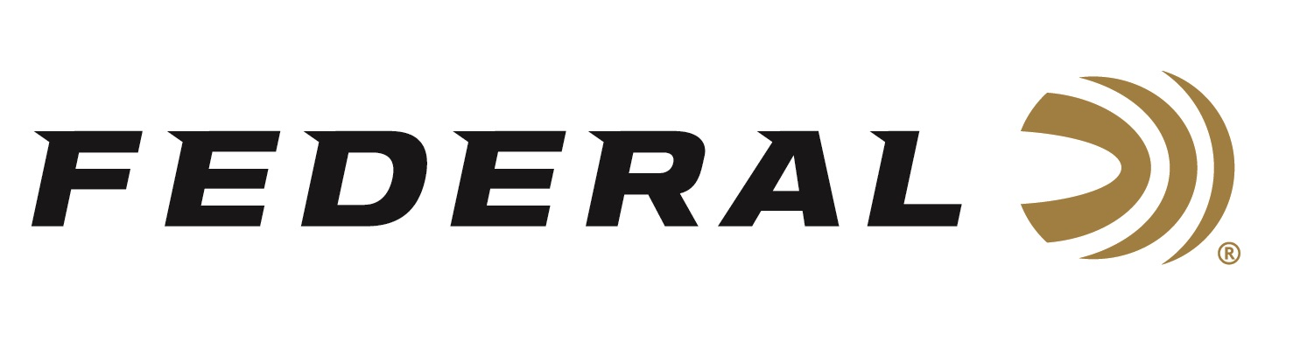

FOR IMMEDIATE RELEASE

Late Season Ducks on “It’s Federal Season” Podcast

ANOKA, Minnesota – December 8, 2022 – On this episode of the “It’s Federal Season” podcast, guest host Janis Putelis of MeatEater talks late season waterfowl with former guide and MeatEater’s resident expert Sean Weaver.

“I’m a novice compared to Sean Weaver and his knowledge of waterfowl tactics,” stated Janis Putelis, of MeatEater. “His passion is unmatched, and he has great advice on tactics, choke selection, recipes and some location recommendations on where to fill the bag with late season ducks and geese.”

Weaver has been a fan of Federal Ammunition and is an advocate for Black Cloud. During this podcast, he highlights the attributes of the best waterfowl ammunition on the market and his preference for shot sizes.

Episode #42 “Late Season Ducks”
https://www.federalpremium.com/this-is-federal/podcast/

For this episode, besides listening on the Federal Premium website or Talk North podcast network, you can also subscribe to Federal Ammunition’s YouTube channel (https://www.youtube.com/user/federalpremiumammo) and tune in for the discussion.

Federal Ammunition can be found at dealers nationwide or purchased online direct from Federal. For more information on all products from Federal or to shop online, visit www.federalpremium.com.

Press Release Contact: JJ Reich
Senior Manager – Press Relations
E-mail: VistaPressroom@VistaOutdoor.com

About Federal Ammunition
Federal, headquartered in Anoka, MN, is a brand of Vista Outdoor Inc., an outdoor sports and recreation company. From humble beginnings nestled among the lakes and woods of Minnesota, Federal Ammunition has evolved into one of the world's largest producers of sporting ammunition. Beginning in 1922, founding president, Charles L. Horn, paved the way for our success. Today, Federal carries on Horn's vision for quality products and service with the next generation of outdoorsmen and women. We maintain our position as experts in the science of ammunition production. Every day we manufacture products to enhance our customers' shooting experience while partnering with the conservation organizations that protect and support our outdoor heritage. We offer thousands of options in our Federal Premium and Federal® lines-it's what makes us the most complete ammunition company in the business and provides our customers with a choice no matter their pursuit.

